Usiel Figueroa
July 09, 2025
CSD 430-A311 Server-Side Development
Module 9 Assignment: Project Part 4

Screenshots (Delete)
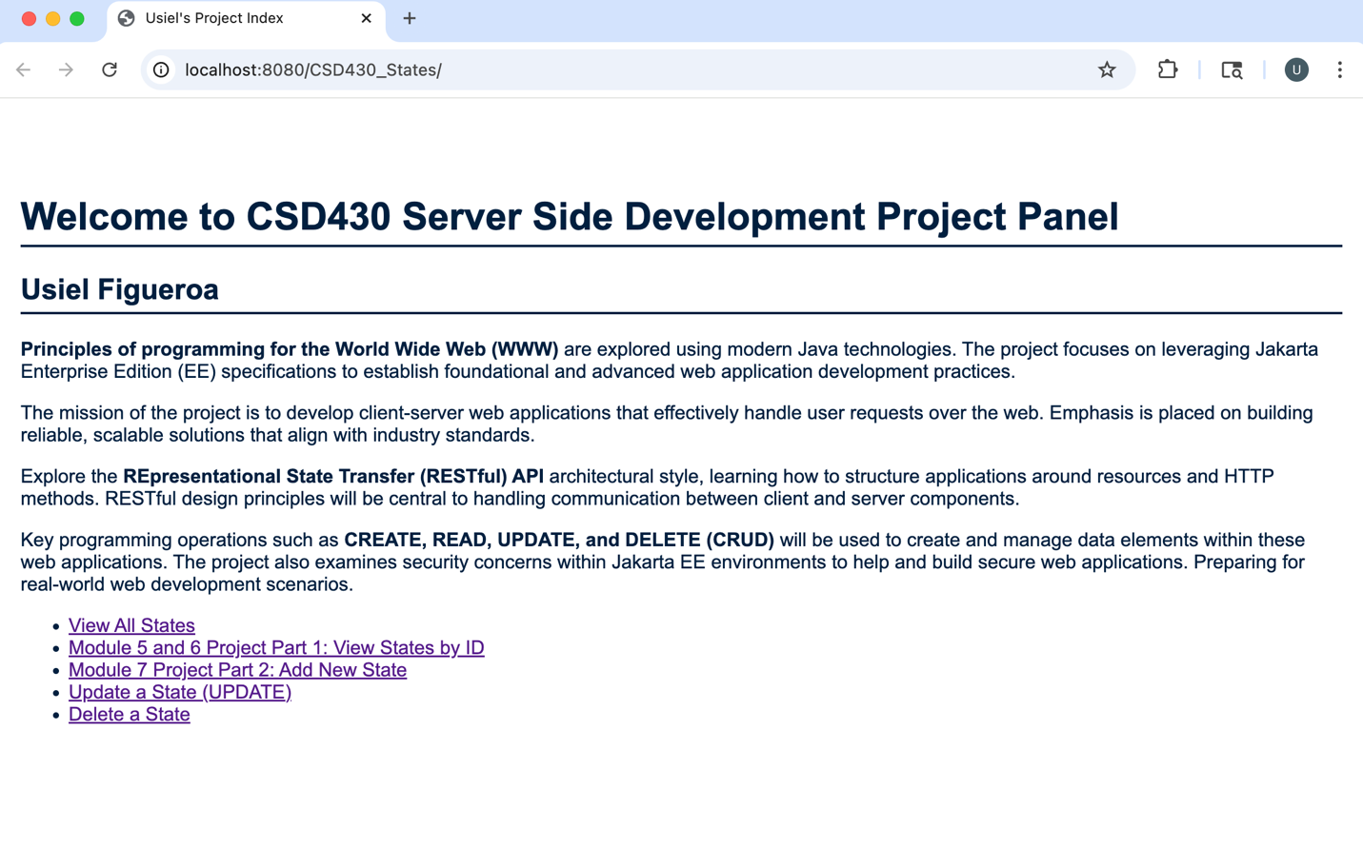
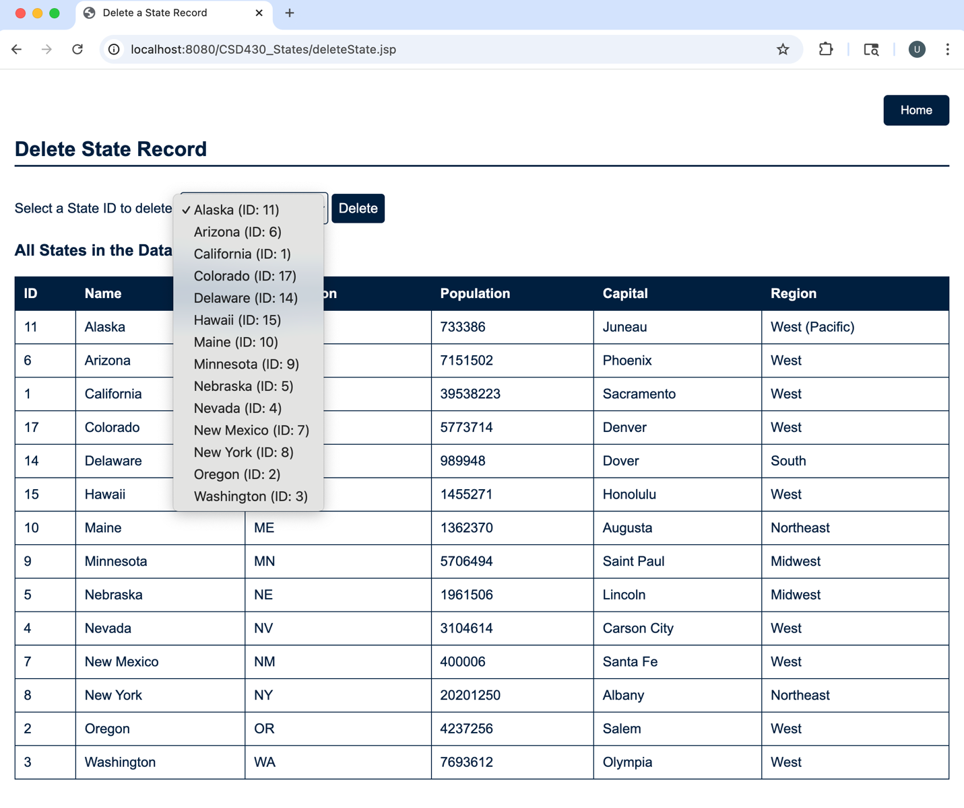
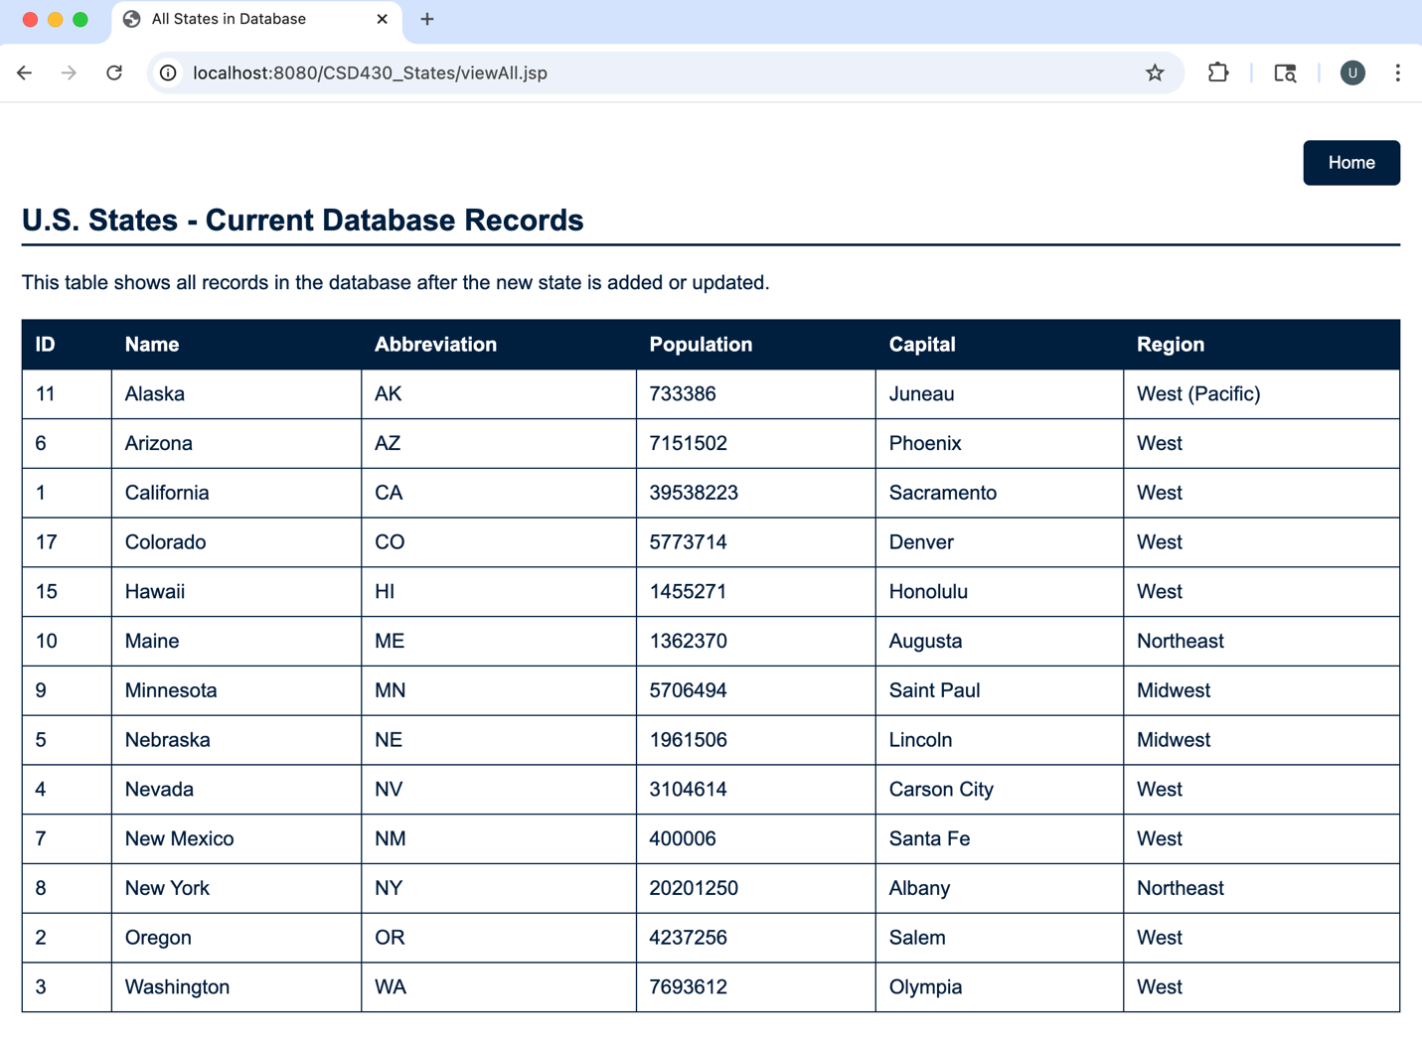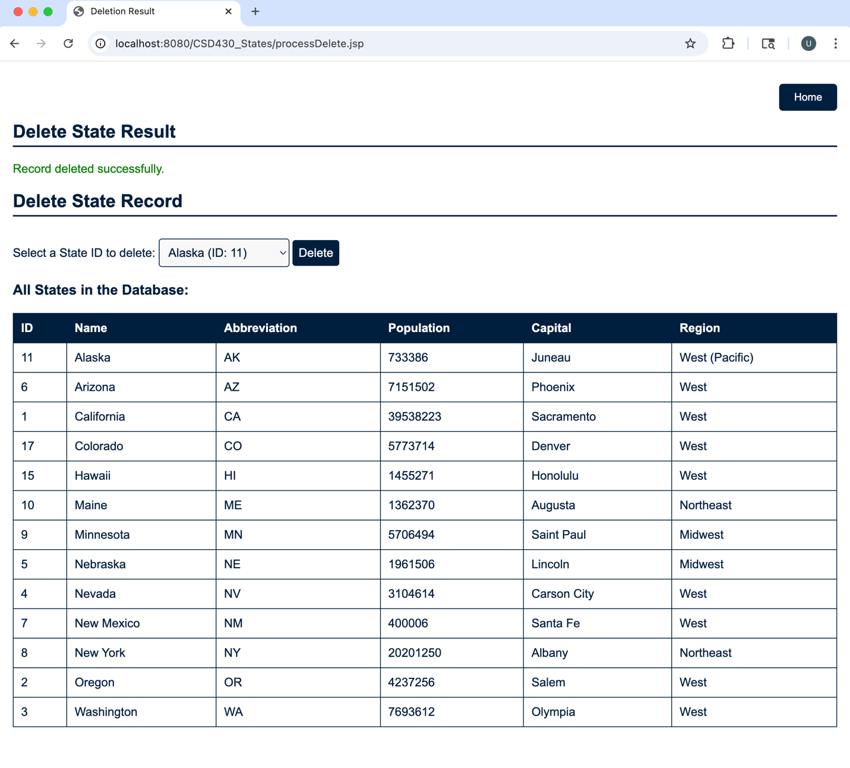Test deleting all records to confirm it still renders a header row and handles empty state gracefully.
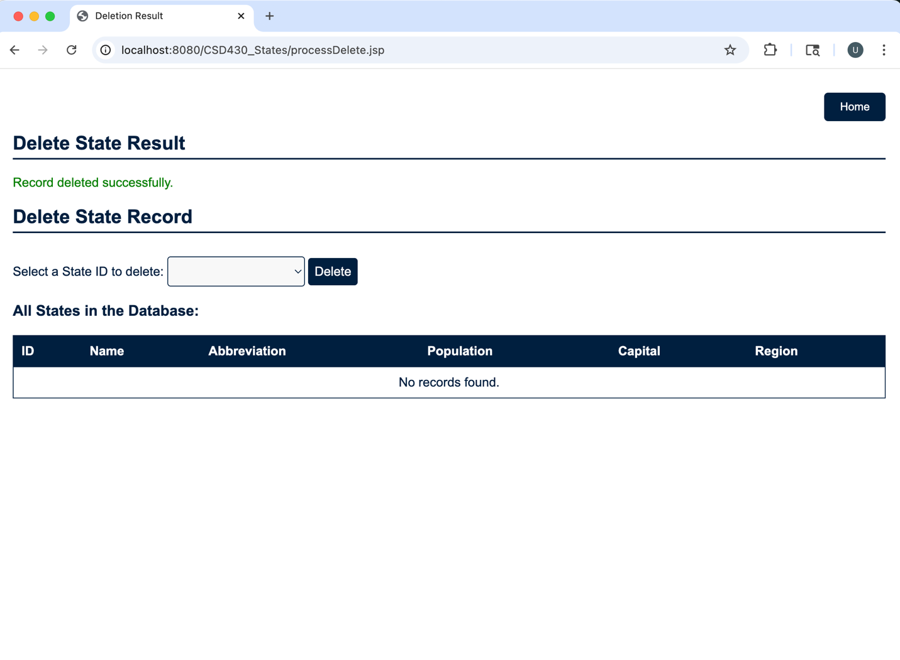

Re- entered new U.S. States
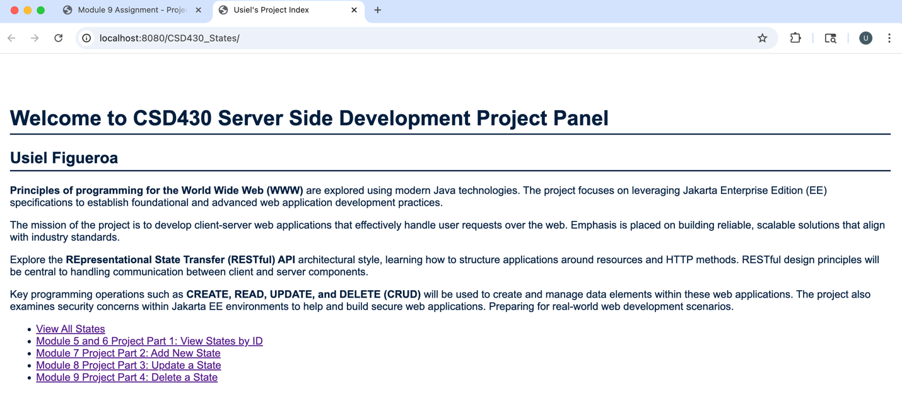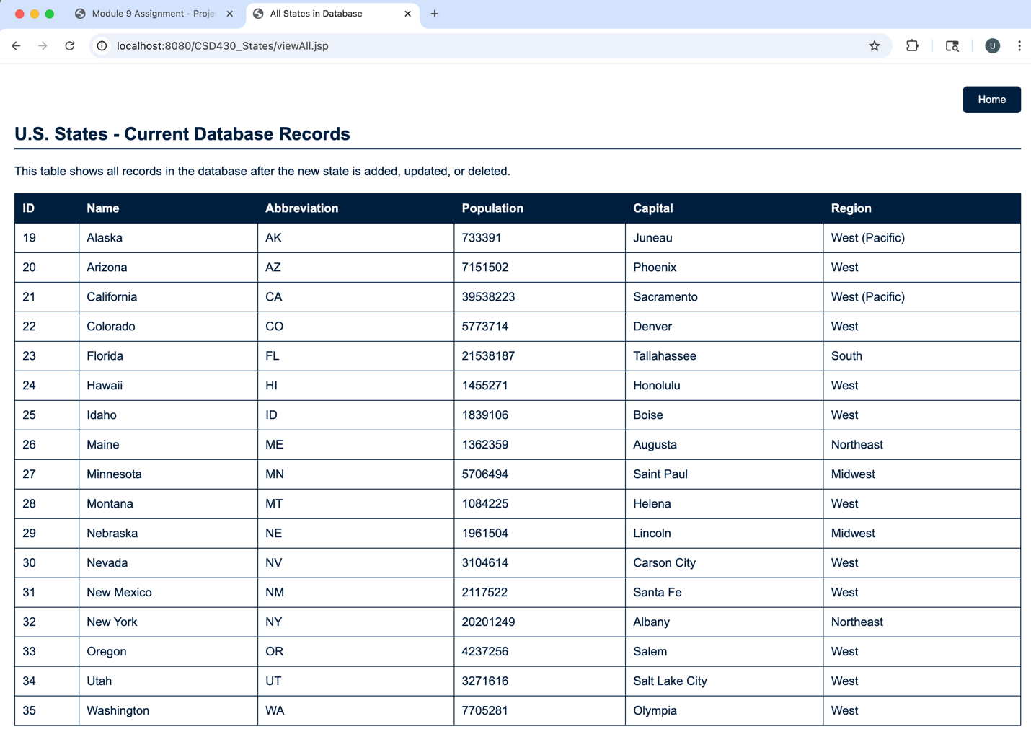

Files
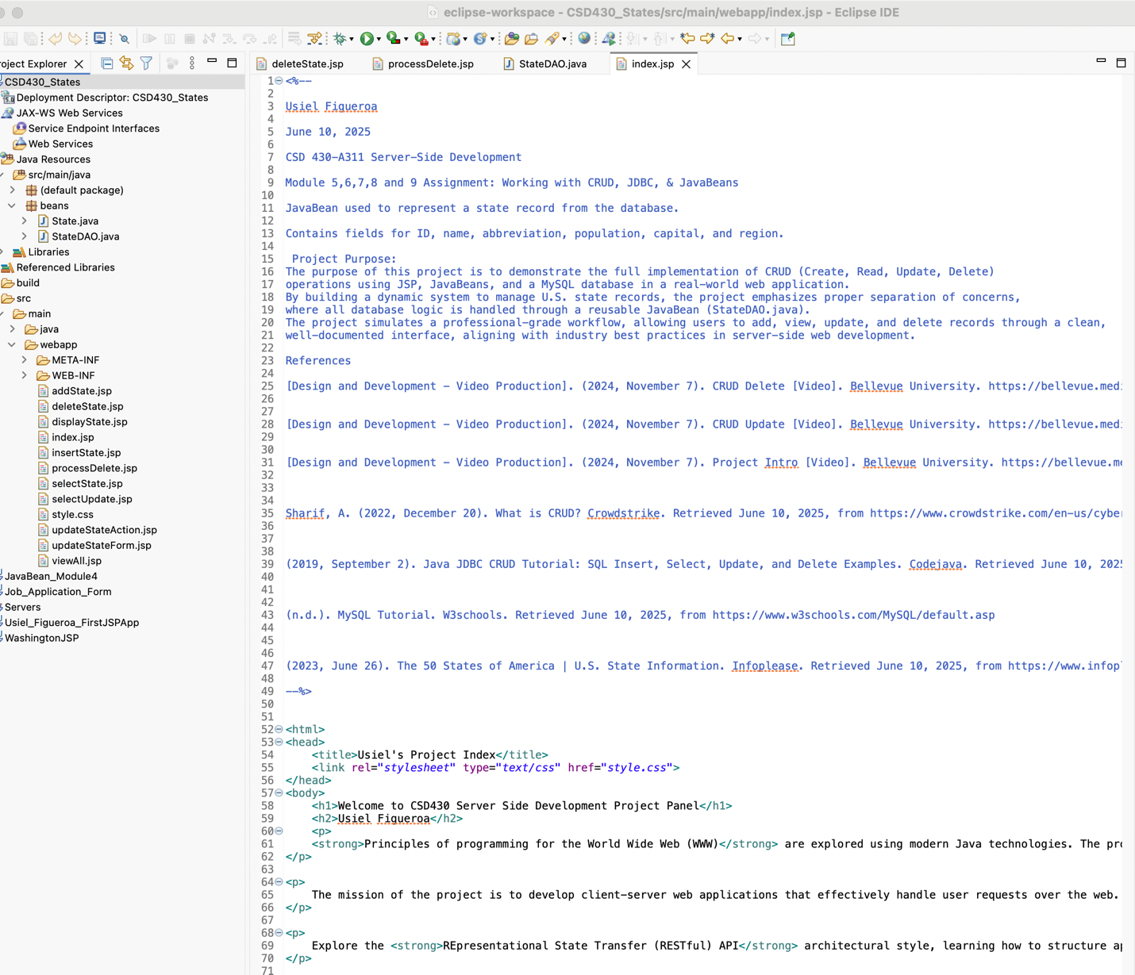
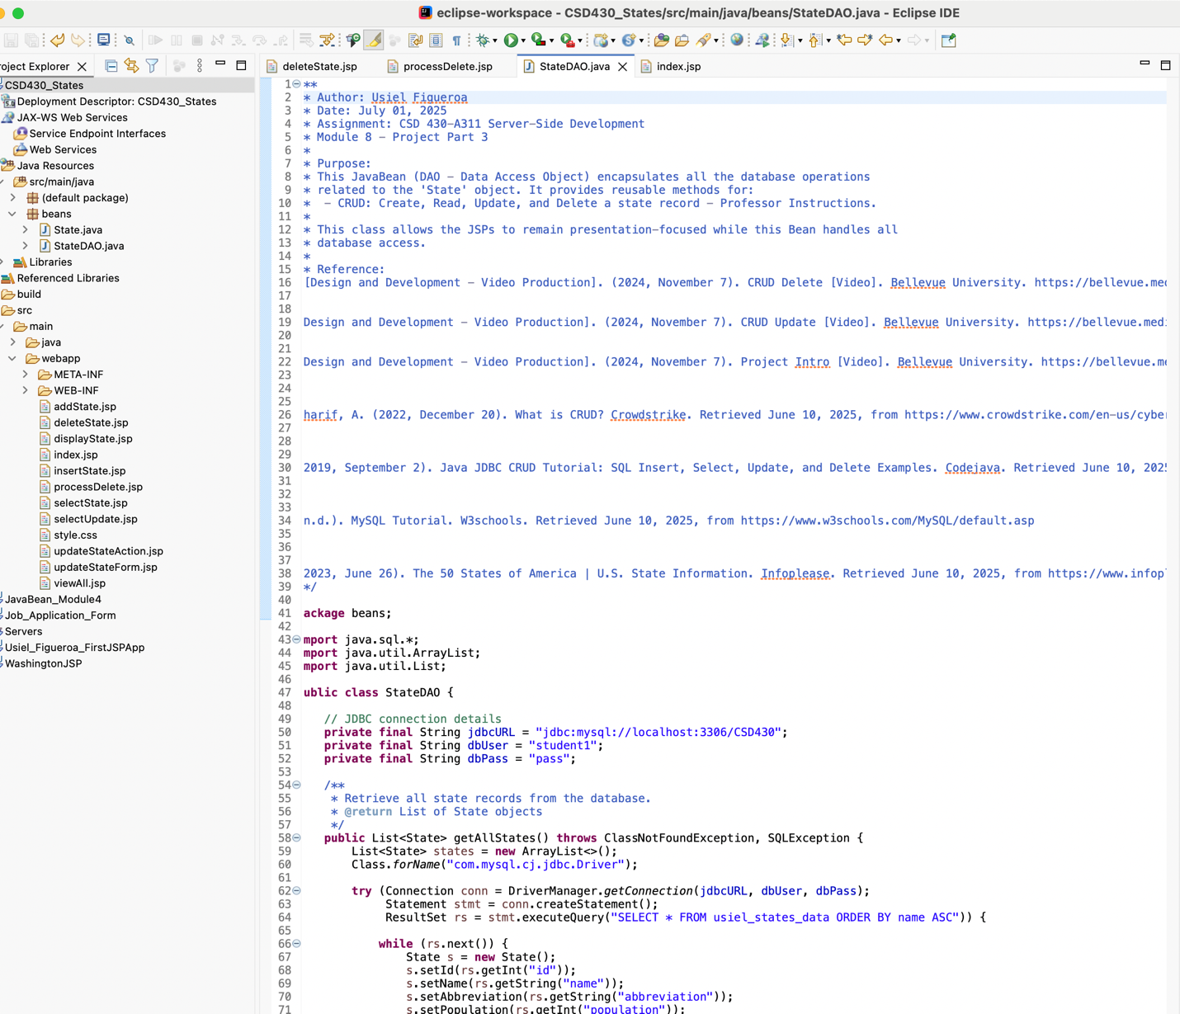
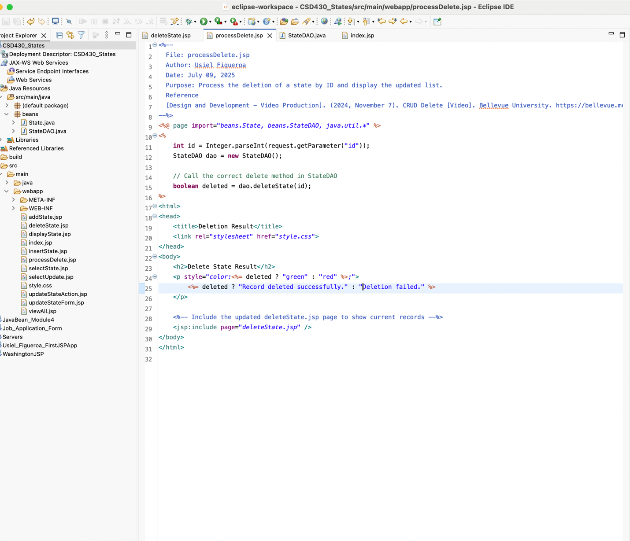
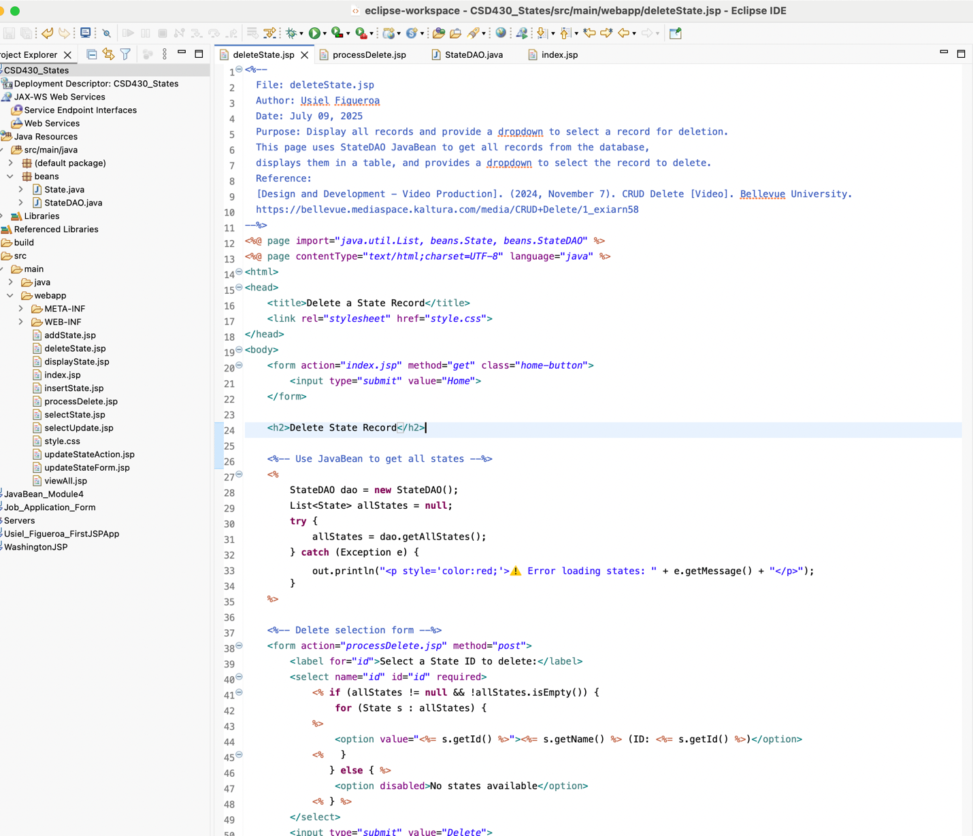

References

[Design and Development - Video Production]. (2024, November 7). CRUD Delete [Video]. Bellevue University. https://bellevue.mediaspace.kaltura.com/media/CRUD+Delete/1_exiarn58
[Design and Development - Video Production]. (2024, November 7). Project Intro [Video]. Bellevue University. https://bellevue.mediaspace.kaltura.com/media/Project+Intro/1_ciyf4naf
Sharif, A. (2022, December 20). What is CRUD? Crowdstrike. Retrieved June 10, 2025, from https://www.crowdstrike.com/en-us/cybersecurity-101/observability/crud/
(2019, September 2). Java JDBC CRUD Tutorial: SQL Insert, Select, Update, and Delete Examples. Codejava. Retrieved June 10, 2025, from https://www.codejava.net/java-se/jdbc/jdbc-tutorial-sql-insert-select-update-and-delete-examples
(n.d.). MySQL Tutorial. W3schools. Retrieved June 10, 2025, from https://www.w3schools.com/MySQL/default.asp
(2023, June 26). The 50 States of America | U.S. State Information. Infoplease. Retrieved June 10, 2025, from https://www.infoplease.com/us/states

